1. **Project profile**

|  |  |
| --- | --- |
| **Company name** | Proses Web Technologies Pvt. Ltd |
| **Project title** | Employee Management System |
| **Project Definition** | An employee management system or EMS is a tool that  helps improve employee satisfaction and productivity to help a company achieve their overall goals. |
| **Project description** | The Employee Management System (EMS) is a software application designed to Management of employee data within an organization. This system provides functionalities for managing employee information, such as personal details, leave requests  **admin:** Admin (Full Rights)  **manager:** employee(Rights) |
| **Aim of Project** | Employee Management System Project is designed to keep track of employee information in any company. It stores data such as their employees' personal information leave  details |
| **Tools/Technologi**  **es** | HTML, JavaScript, React, Bootstrap, MySQL, Node |
| **Duration** | 4 Month |
| **Team Size** | 1 |
| **Type** | Web Application |
| **Internal guide** | **Prof. Minal Shah** |
| **External guide** | **Mr. Parthiv Shah** |

## Project Definition

An employee management system is a system that helps to improve employee management and productivity to help a company achieve their overall goals. These system help monitor, assess and control employees' working hours. It include Manager efficiently manages each employee's information and distribute salaries.

With the help of employee management system the Manager department can implement processes and help companies achieve their business objectives. By helping managers keep track of admin activities, the system can help improve employee engagement and increase productivity. These system also help an organization for Leave management.

# System Requirement Specification

1. **Introduction**

The Employee Management System (EMS) is a software application designed to streamline the management of employee data within an organization. This system provides functionalities for managing employee information, such as personal details,attendance, leave requests, performance evaluations, and payroll processing.

## Purpose

The purpose of this document is to define the requirements for the development of an Employee management to manage Human resource effectively as well as efficiently by the employer. The system is created for the core purpose is to manage employee things and togetherness of three core tires of every organization. And being helpful to an organization.

## Definition

The Employee management system describes the management of employee and all the authorization are in the hands of admin and some of part through the manager.

## Scope

The Employee management system is used by human resource managers as well for analysers of any organization. It includes salary of every employee, admin can add, update, delete employee, admin can also modify data within the system as well as leave of employees are goes under the managers.

## Intended Audience and Users

#### Human Resources (HR) Professionals:

These are the main users of Employee management system. They have to work on their human resource and make them feel better as well as via less efforts. All this requirements can filled up by the Employee management system.

#### Decision-makers:

Decision-makers, including executives and organizational leaders they have to analyse on organizations man power as well as they can take decision regarding new joining as well as their management.

#### Data Analysts:

Another important audience is data analyst. Their main work is to analyse employee data while distributing allowances, their expenses on their human property.

# Overview

## Environmental Characteristics

### Hardware/Software Software

Name of component Specification

Operating System Windows7, Windows10, Windows11

Language React, HTML, JavaScript, Bootstrap, CSS.

Database MySQL Server

Browser Chrome, Internet Explorer, Microsoft Edge

Web Server Apache

Software Development Kit Node

Scripting Language Enable JavaScript

### Hardware

Name of component Specification

Processor Intel(R) Core (TM) i5-5200U

Monitor 15” Color Monitor

RAM 8 GB

Hard disk 20GB

Keyboard 122 Key

### Peripheral

No specific peripheral hardware is required for accessing the Dashboard of Employee management system. Employee, manager and admin can interact with the platform using standard input devices such as keyboards and mice, along with displays (monitors/screens) for visualizing the data.

### People

#### Development Team:

**Software Engineers:** Responsible for developing frontend and backend

components, implementing features, and ensuring system functionality.

**UI/UX Designers:** Design user interfaces, wireframes, and prototypes for optimal user experience.

#### End-users:

**Employee:** This are the vital role who use this system. To show their profile, attendance, salary.

**Admin:** The handler or in other words primary user which handles the data, authorizations, protocols etc.

**Managers:** The middleware or which are being monitors of the Employee Management System.

**Human Resources Managers:** Use demographic and income data to understand workforce characteristics and plan recruitment strategies.

## Overview

The Employee Management System is used to handle employee data and being easy handler to manage human force and their profiles.

## Acronyms & Abbreviation

Employee Dashboard (ED): The web-based platform designed to

showcase Employee data.

EMS: Employee Management System

HRMS: Human Resource Management System HRIS: Human Resources Information System EHR: Employee Health Record

EIS: Employee Information System TMS: Talent Management System ATS: Applicant Tracking System

PMS: Performance Management System T&A: Time and Attendance

DMS: Document Management System

## References

Human resource activities Node libraries

# Specification Requirements/ Functional Requirements

* A log in facility for enabling only authorized access to the system.
* System administrator will be able to add, modify, enable, disable or delete anyfeature like, employee information, and login information.
* System administrator will be able to create login credentials for new employees.
* Employees will be able to view their information.
* An employee cannot view other employee details.

## User Authentication

**Requirement 3.1.1:** Users must authenticate themselves before accessing the Employee management dashboard.

**Requirement 3.1.2:** Authentication mechanisms such as Email and password.

## User Interface

**Requirement 3.2.1:** The dashboard shall display various navigates to Display employee data.

**Requirement 3.2.2:** Admin can add and update employee and employee can get data.

## Various roles

**Requirement 3.3.1:** There is 3 roles and all of them can get their Screens. There are Employee, manager, admin.

## User Class

### Attributes

Employee ID: A unique identifier for each employee. Name: The full name of the employee.

Username and Password: For user authentication and access control. Contact Information: Such as email.

Position: The position or role of the employee within the organization. Department: The department to which the employee belongs.

### Methods

Getters and Setters: For accessing and updating the attributes of the user.

Authentication: Verify the username and password for login purposes.

Update Profile: Allow the user to update their contact information. View Personal Information: Display the employee's details.

### Access Control

Authorization Check: Ensure that the user has the necessary permissions for certainactions or access.

### Password Management

Password: passwords, ensure they are secure.

### Relationships

Manage Relationships: If the system involves hierarchical relationships or reportingstructures, the User class may need methods to manage these relationships

# Non-Functional Requirements

* Employees never allowed to modify their or other employee’s information. Suchattempt will be reported to the administrator.
* Employees can change their password when they wan

## Accessibility, Reliability and Availability, Performance, Security

#### Accessibility:

The Employee Dashboard shall comply with accessibility standards, ensuring that it is accessible to users with disabilities. This includes:

* + Providing alternative text for images and visual elements for screen readers.
  + Ensuring keyboard navigation functionality for users who cannot use a mouse.
  + Maintaining adequate colour contrast and font sizes for readability.

#### Reliability and Availability:

The Employee dashboard shall have a reliable uptime of at least 99%, ensuring that it is consistently available for employees.

* + Regular maintenance and updates to address any potential issues promptly.
  + Monitoring system performance and availability to proactively identify and resolve any issues.

#### Performance:

The Employee dashboard shall load within 3 seconds on standard internet connections to ensure optimal user experience. This includes:

* + Optimizing front-end and back-end code to reduce loading times.
  + Implementing caching mechanisms to speed up data retrieval and rendering processes

#### Security:

The Employee dashboard shall ensure the security of data transfer and storage to protect sensitive information.

* + Implementing encryption protocols such as HTTPS for secure data transmission over the network.
  + Utilizing secure authentication mechanisms to restrict access to authorized users only.
  + Regular security audits and updates to address any vulnerabilities and ensure compliance with industry standards.

## Interfaces

### User Interfaces

The Employee dashboard shall have an effective and user-friendly interface that allows users (Employee, manager, admin) to interact with data and display features efficiently.

### Software Interfaces

The Employee dashboard shall integrate with various software components and services to support its functionality. This includes:

Integration with frontend frameworks such as React for building user interfaces. Integration with backend frameworks such as Node for handling server-side logic and APIs.

Integration with database systems such as MySQL and Mongo DB for data storage and retrieval.

### Communication Interfaces

The Employee dashboard shall support communication interfaces for exchanging data and information between different components. This includes:

APIs and web services for communicating with external files and data sources. Such as database

# Behavioral Description

## System States

#### Admin Login State:

Transitioned to when an admin logs into the system. The system authenticates the usercredentials.

#### Employee Login State:

Transitioned to when an Employee logs into the system. The system authenticates the user credentials.

#### Manager Login State:

Transitioned to when a Manager logs into the system. The system authenticates the user credentials.

#### Employee Information Viewing State:

Entered when a user accesses the employee information module. The system displays employee details.

#### Manager Information Viewing State:

Entered when a user accesses the Manager Information module. The system displaysrelevant Manager Details.

#### Admin Information Viewing State:

Entered when a user accesses the Admin Information module. The system displaysrelevant admin details.

#### Manager Information Editing State:

Entered when a manager is authorized to edit Manager Information and Employee Information. The system allows modifications to Manager and Employee records.

#### Admin Information Editing State:

Entered when an admin is authorized to edit admin information, Manager Information, Employee Information. The system allows modifications to admin, employee and manager records.

#### New Employee State:

Entered when a user initiates the on-boarding process for a new employee. The system prompts the Manager and admin to enter relevant information for the new employee.

#### Leave Request State:

Transitioned to when an Employee logs into the system. The system authenticates the employee credentials. And employee can apply leave and manager have rights to approve and decline leave Request.

## Events and Actions

#### Admin Login Event:

Action: The system verifies Admin credentials and transitions to the Login State if successful.

#### Manager Login Event:

Action: The system verifies manager credentials and transitions to the Login State ifsuccessful.

#### Employee Login Event:

Action: The system verifies employee credentials and transitions to the Login State ifsuccessful.

#### View Employee Information Event:

Action: The system retrieves and displays the relevant employee information.

#### View Admin List Event:

Action: The system retrieves and displays the relevant admin list.

#### View manager Information Event:

Action: The system retrieves and displays the relevant manager information.

#### Edit Employee Information Event:

Action: The system allows the user to modify employee records after proper authorization.

#### Edit Admin Information Event:

Action: The system allows the user to modify admin records after proper authorization.

#### Edit Manager Information Event:

Action: The system allows the user to modify manager records after proper authorization.

#### Admin Logout Event:

Action: The system returns to the Idle State.

#### Manager Logout Event:

Action: The system returns to the Idle State.

#### Employee Logout Event:

Action: The system returns to the Idle State.

# System Design

**4.1 Architectural diagram**

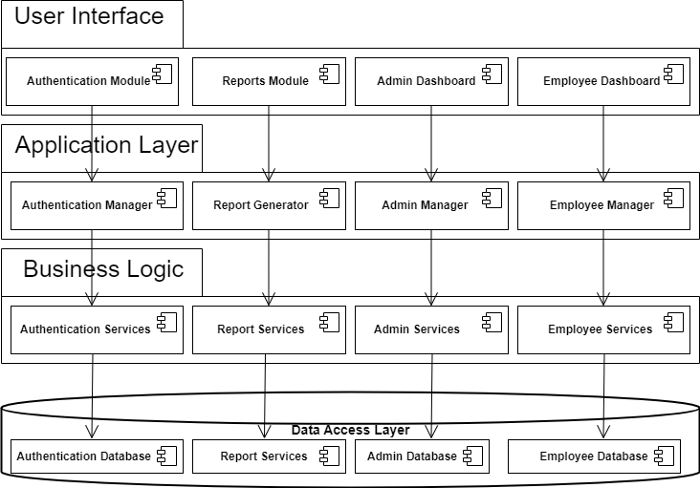

# 4.1.1 Use case Diagram

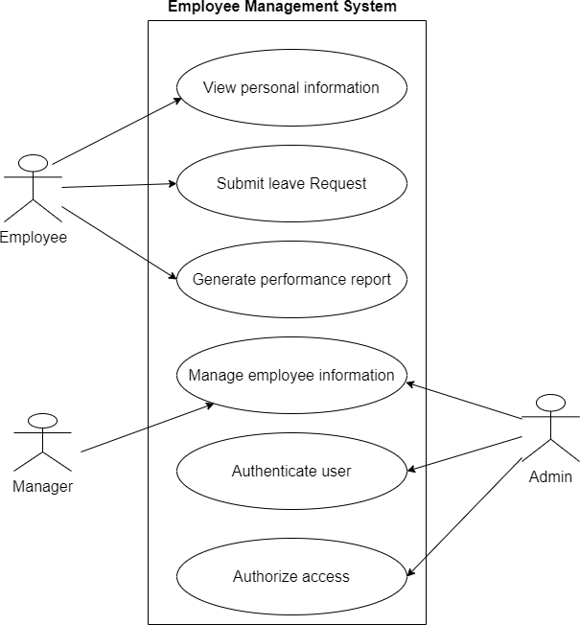

**4.1.2 Activity Diagram**

## Employee Activity

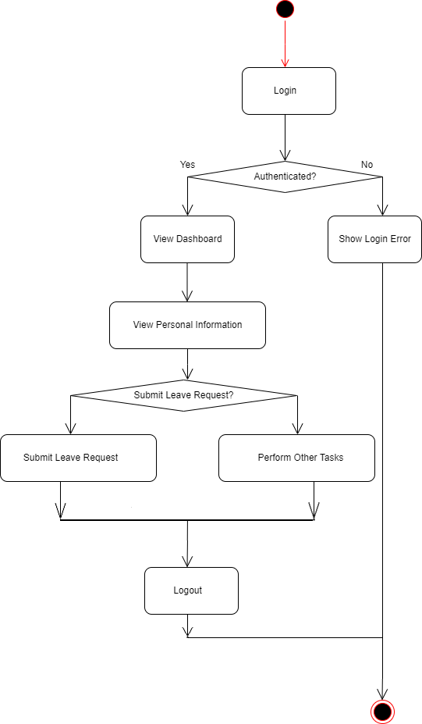

**Manager Activity**

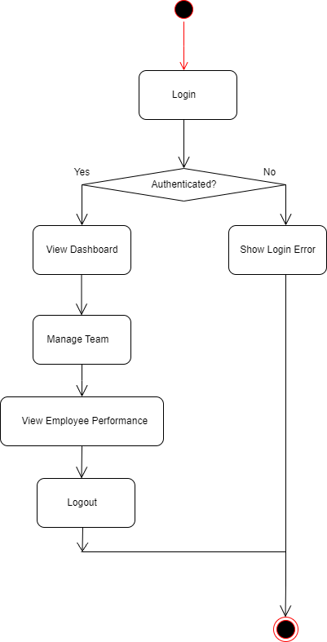

**Admin Activity**

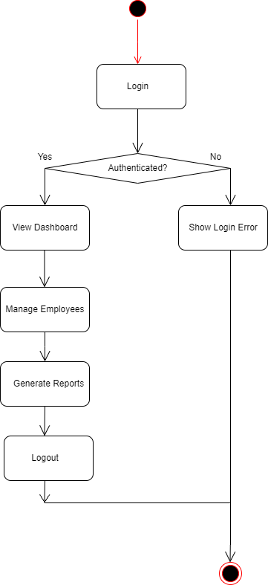

# 4.1.3 Class Diagram

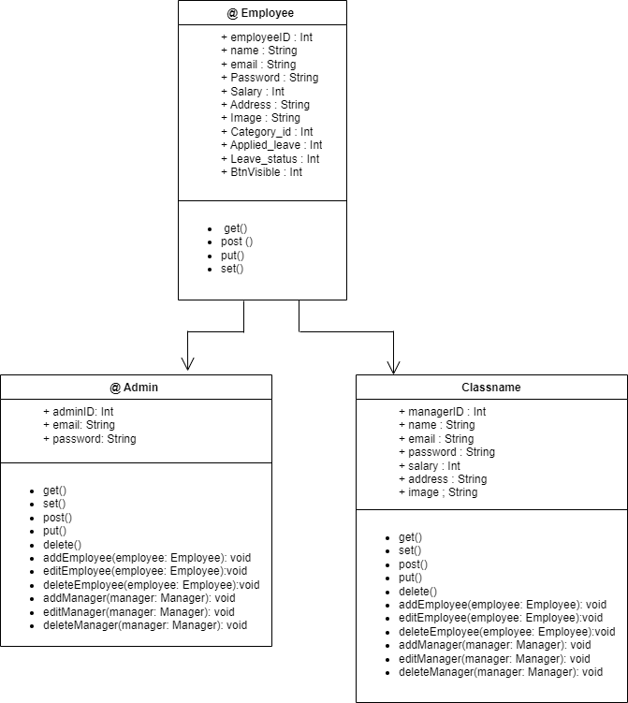

**4.1.4 Sequence Diagram**

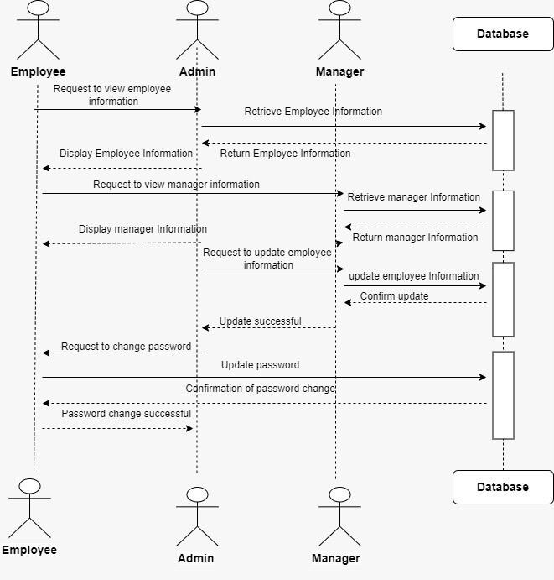

1. **ER Diagram**

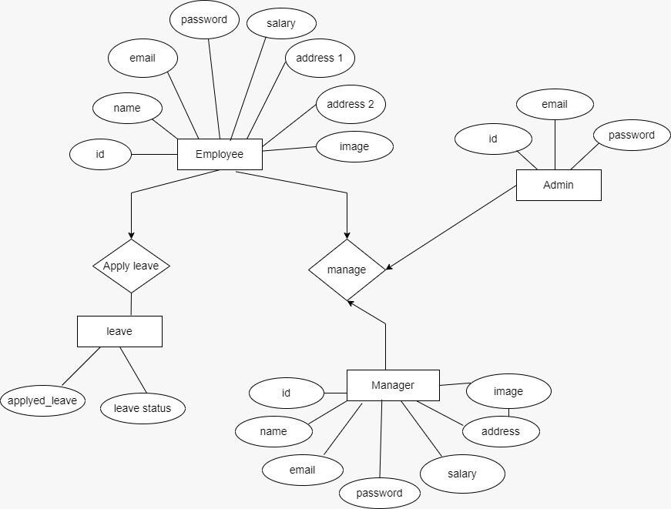

1. **Implementation Screenshot**

**6.1 Screen Snapshots**

## Employee Module

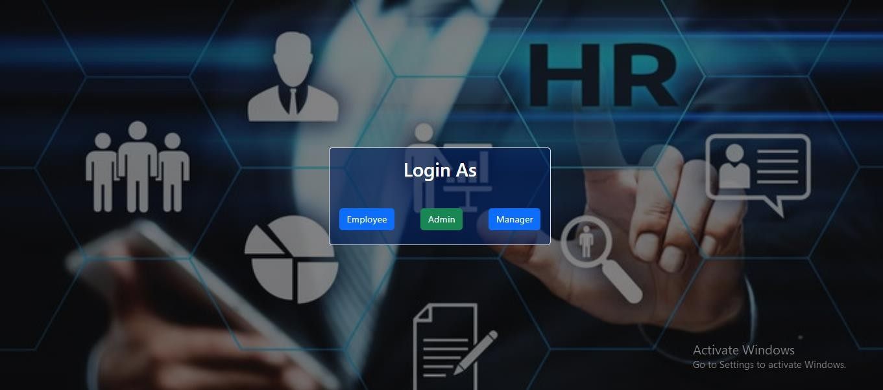

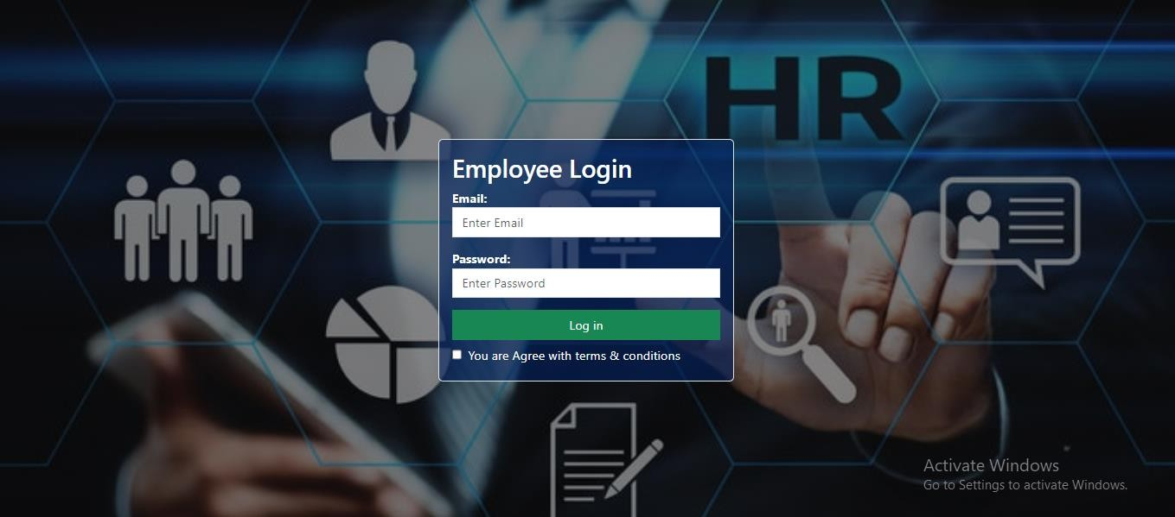

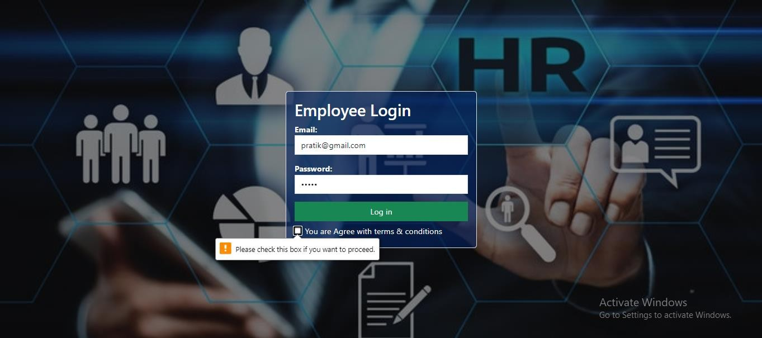

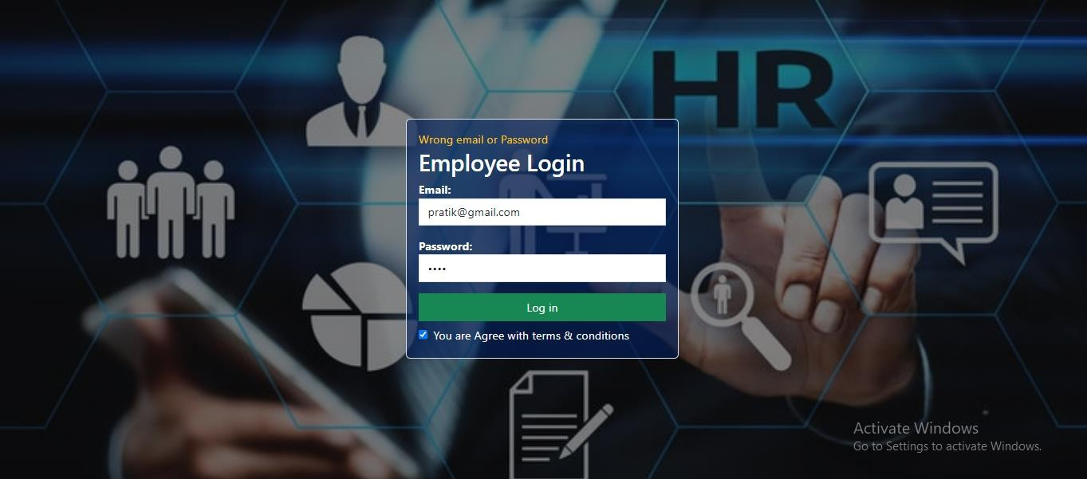

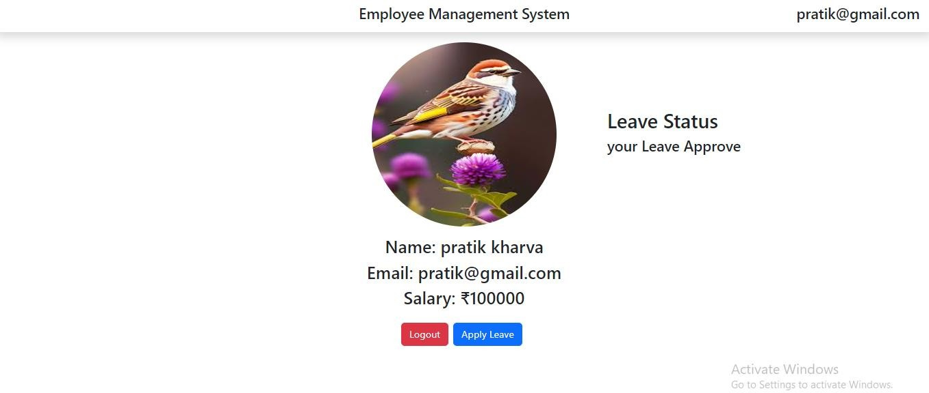

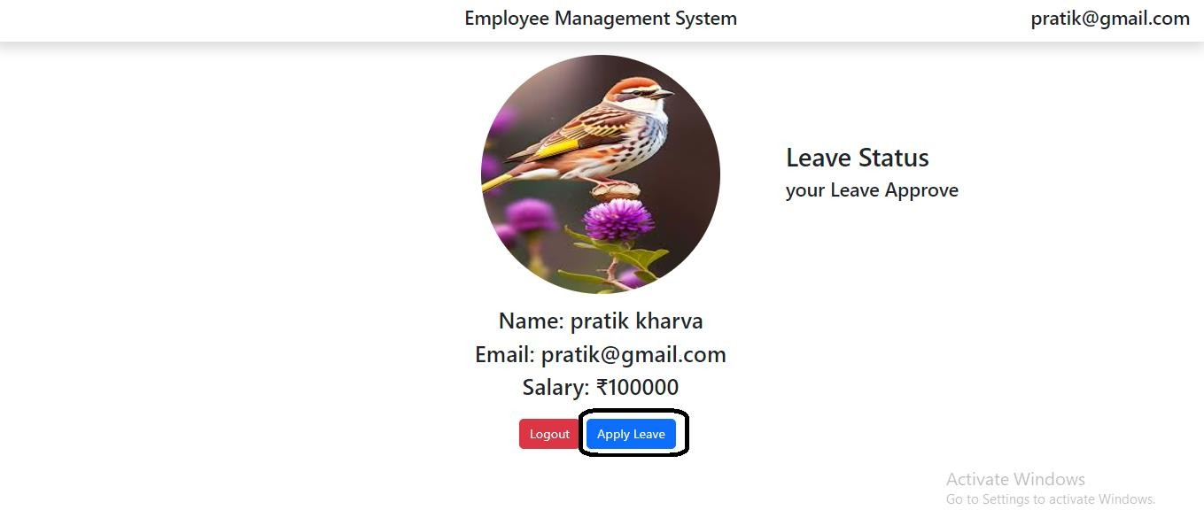

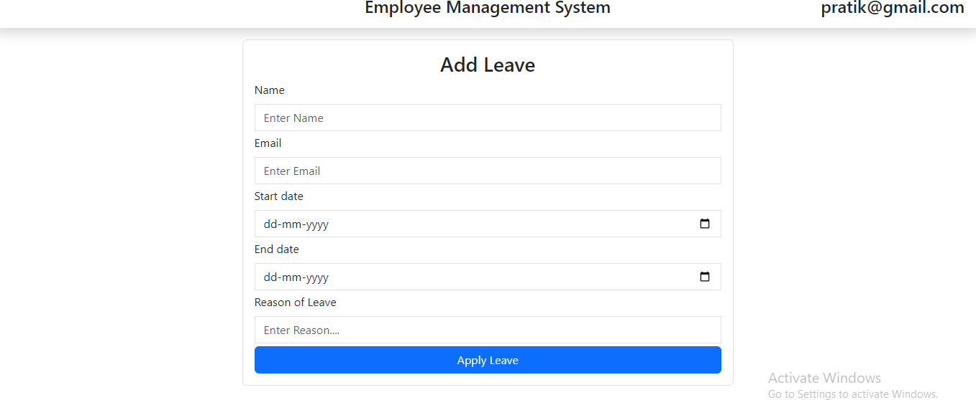

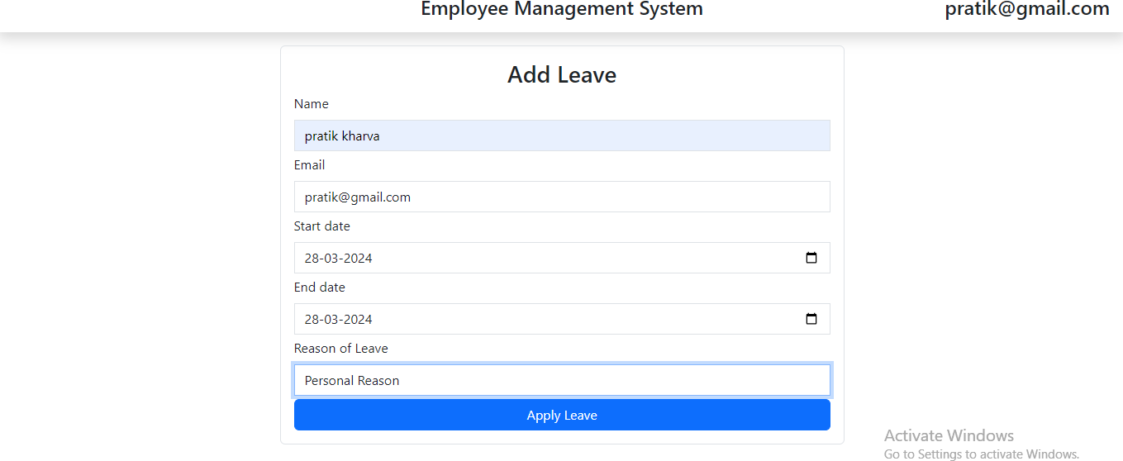

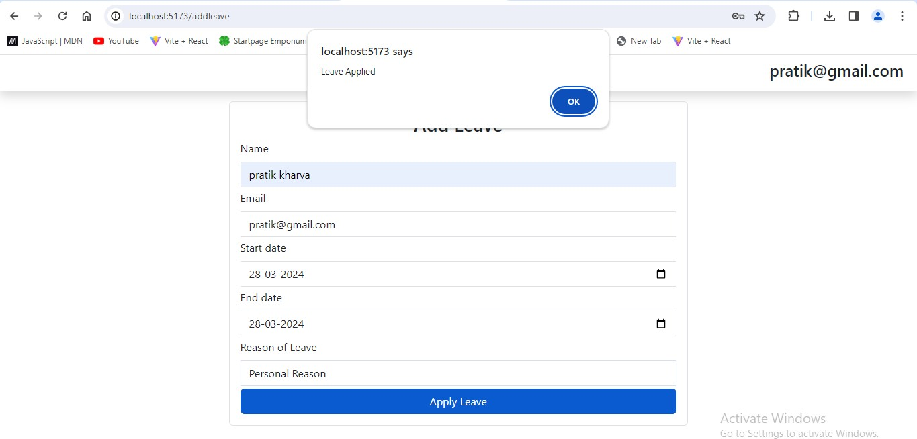

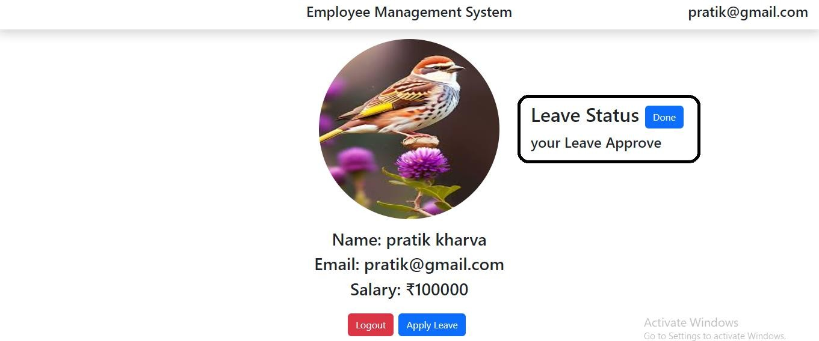

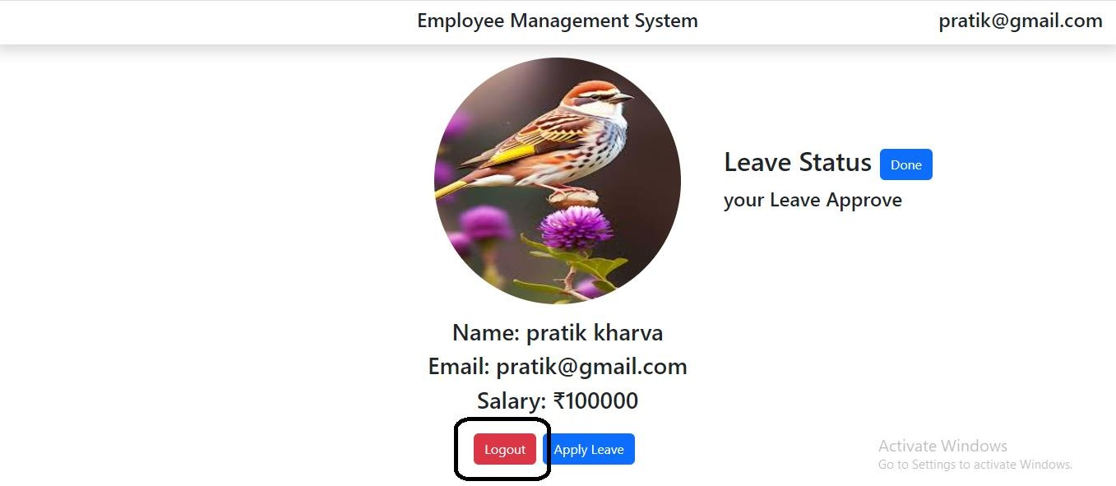

**Admin Module**

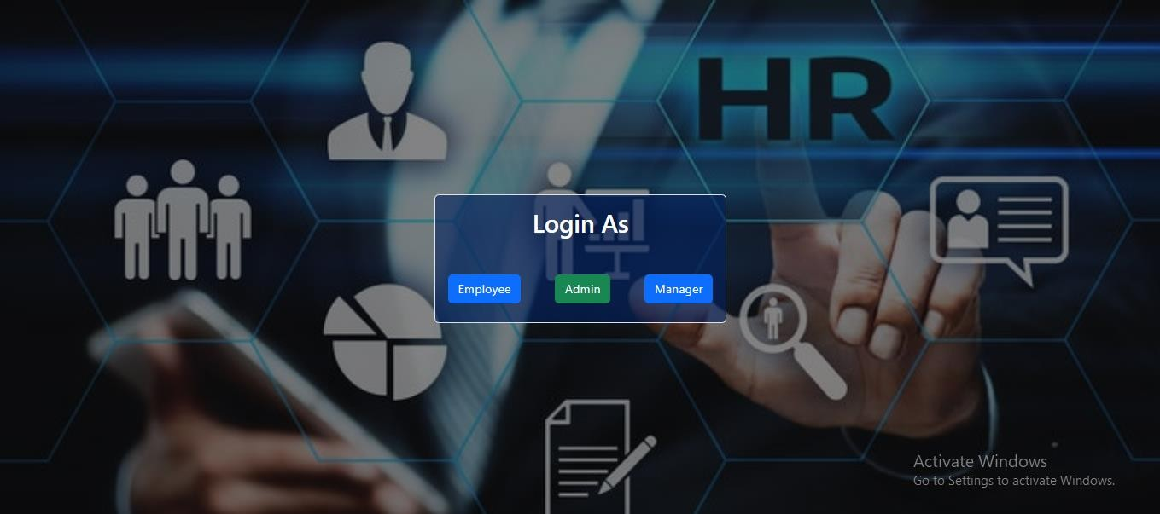

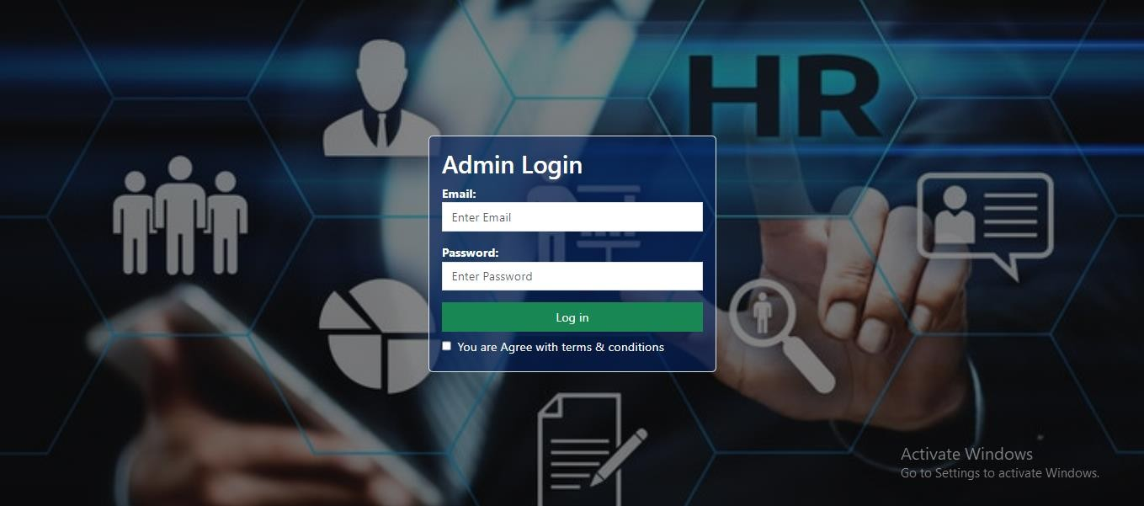

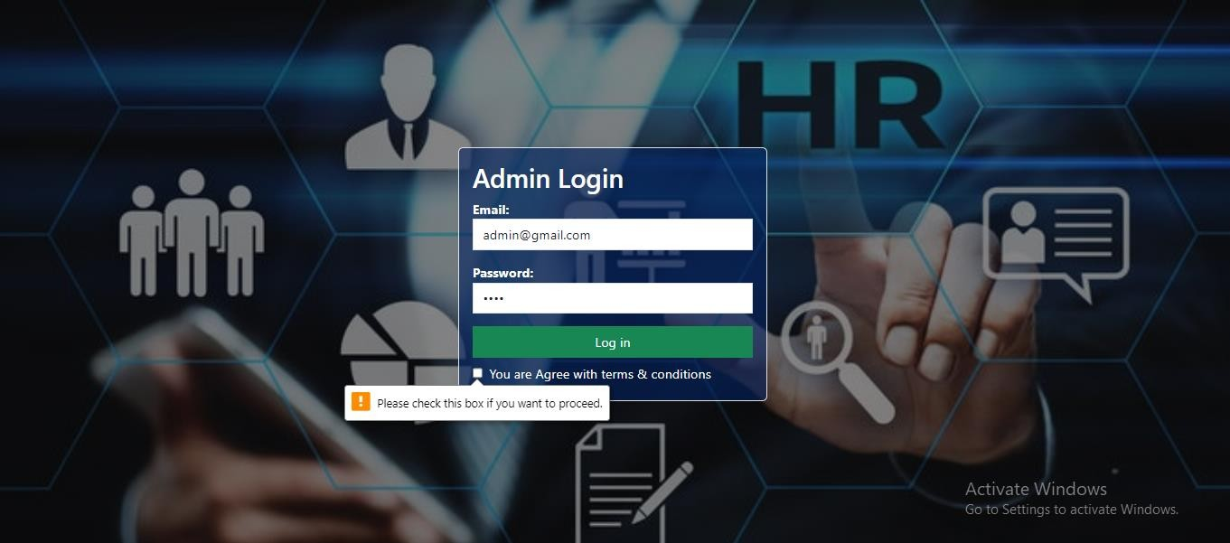

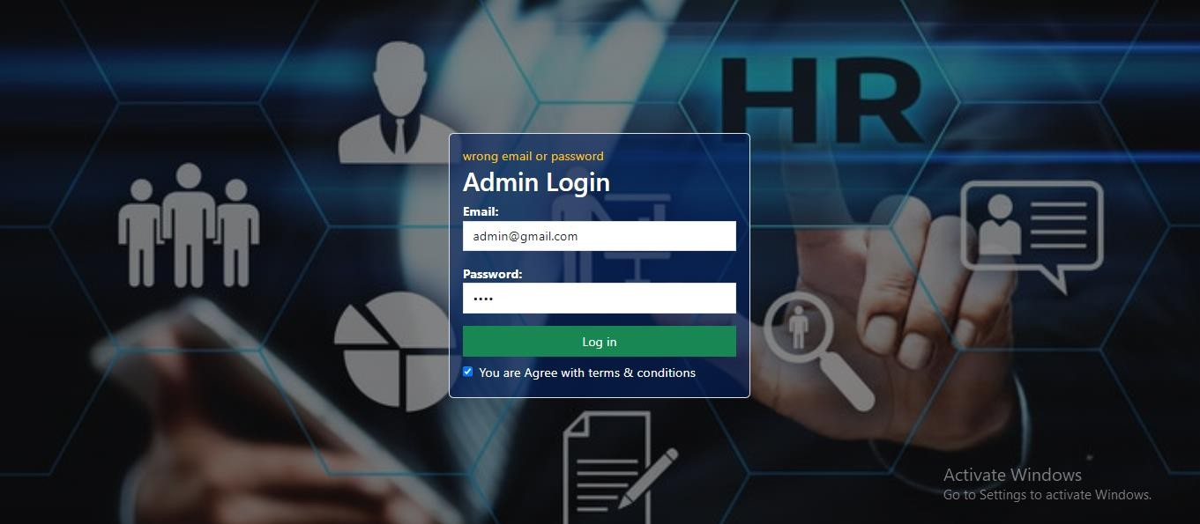

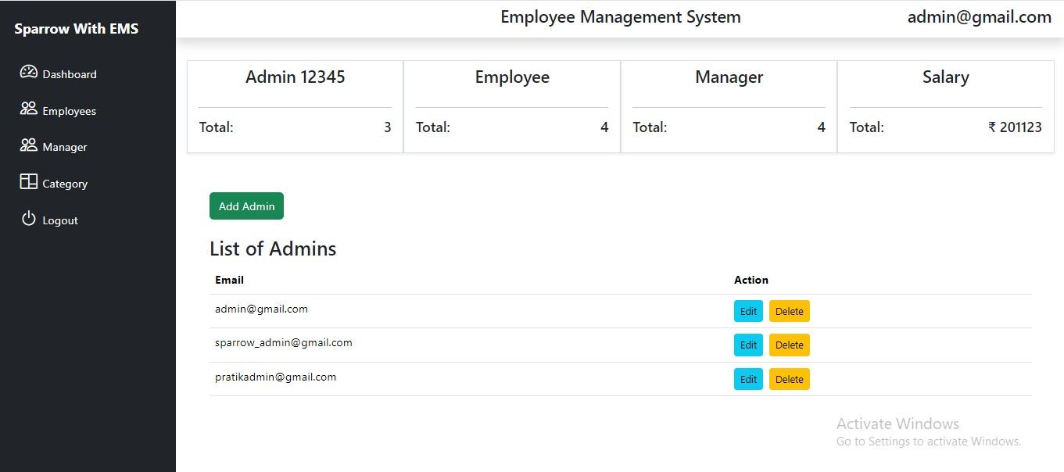

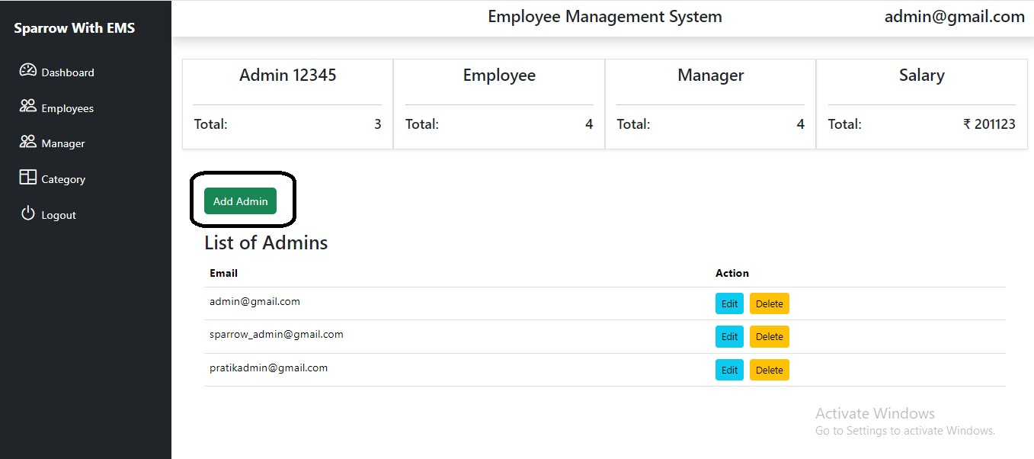

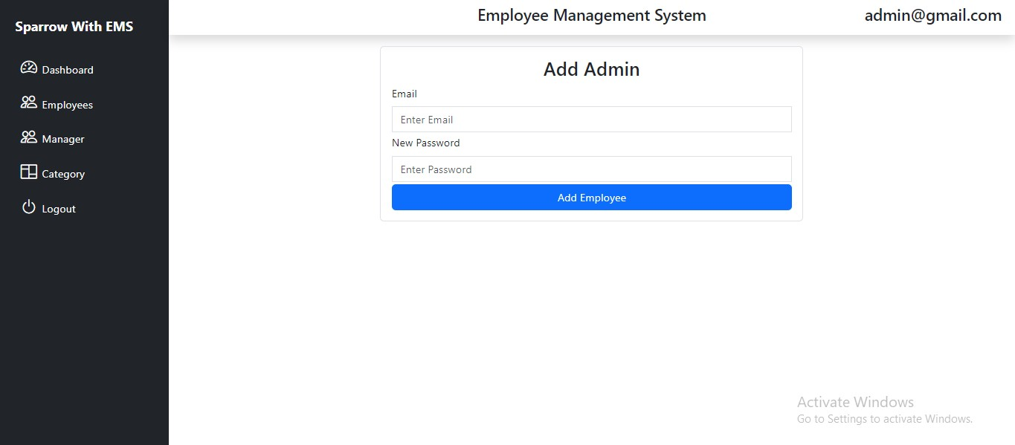

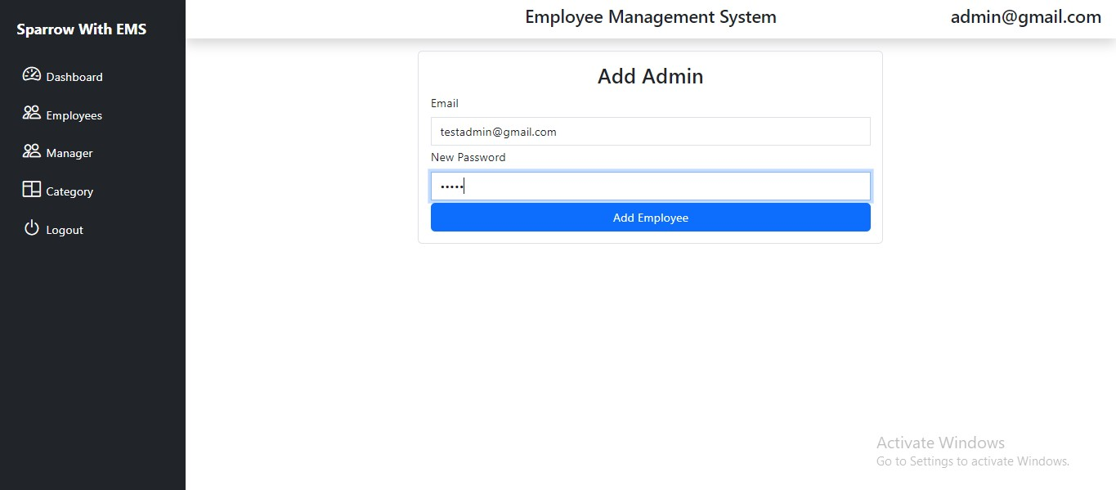

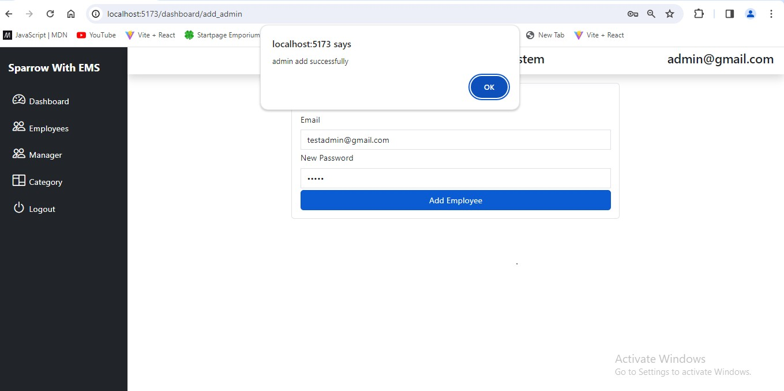

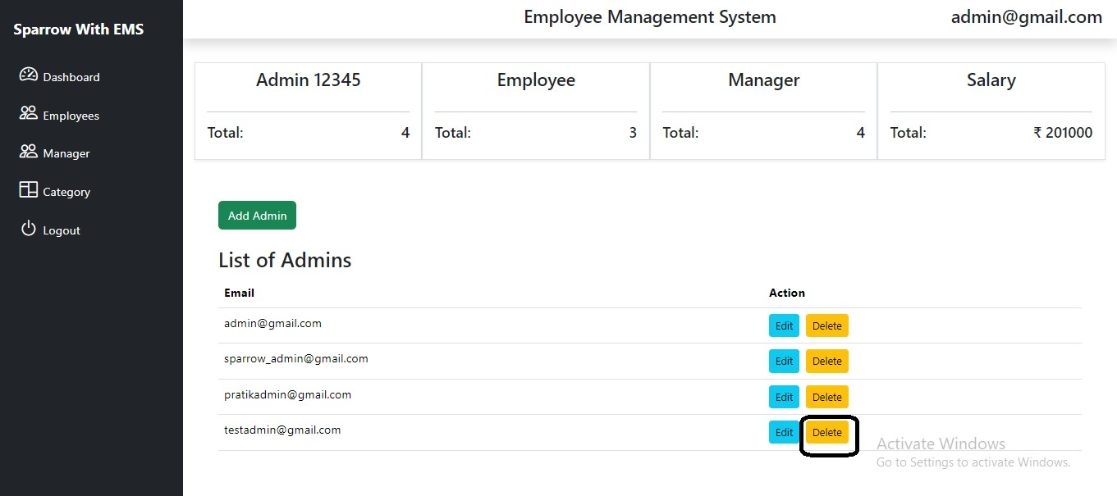

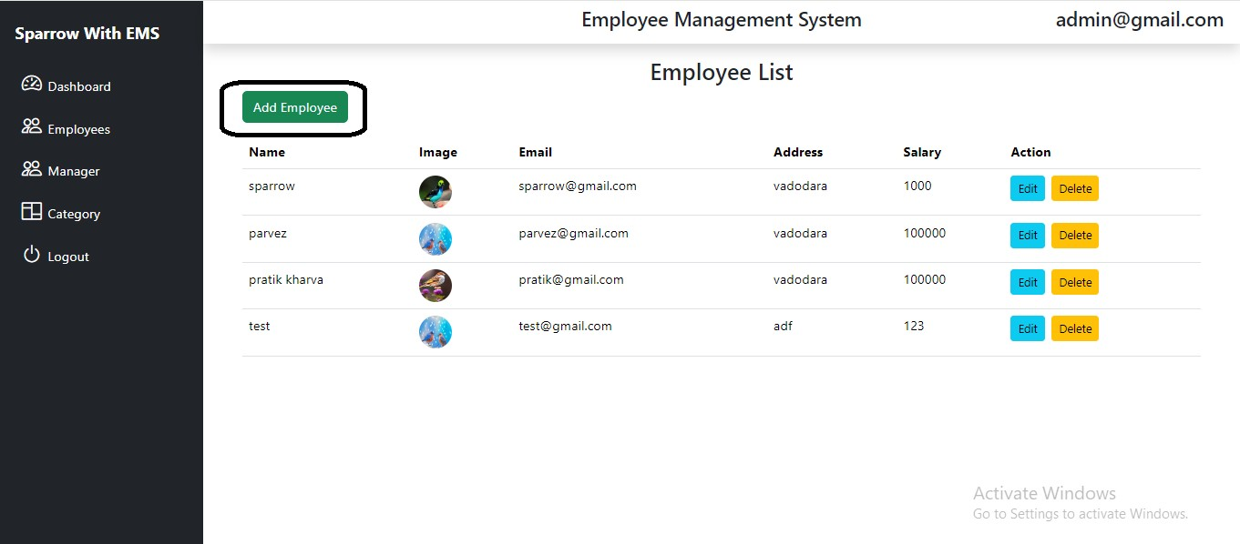

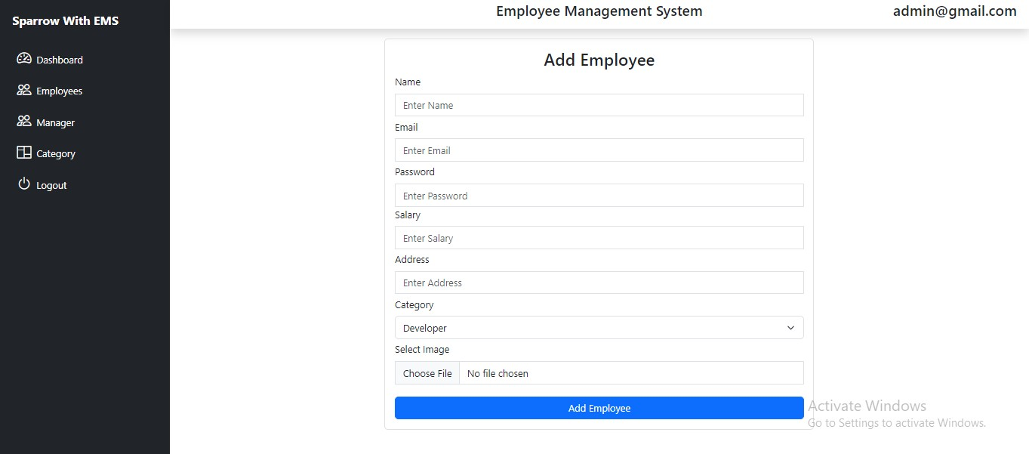

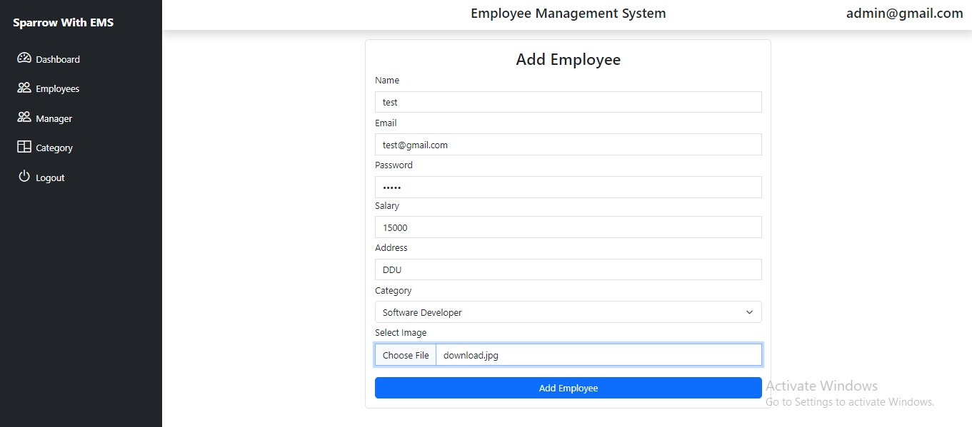

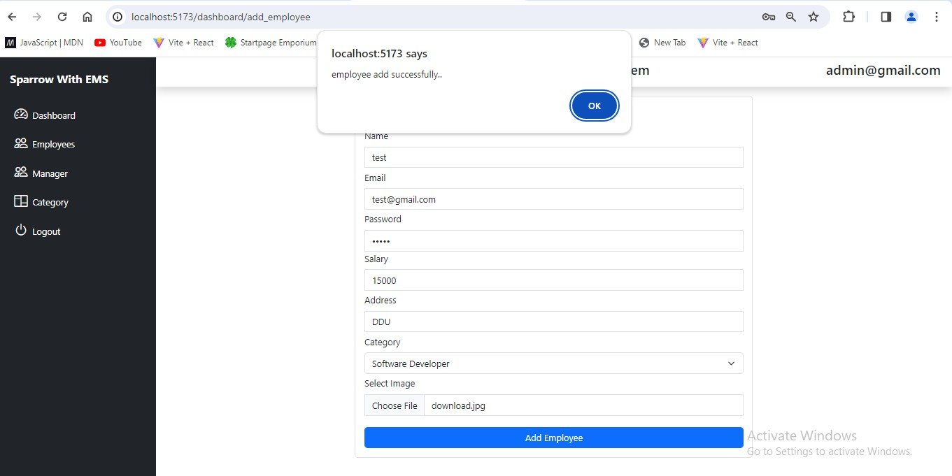

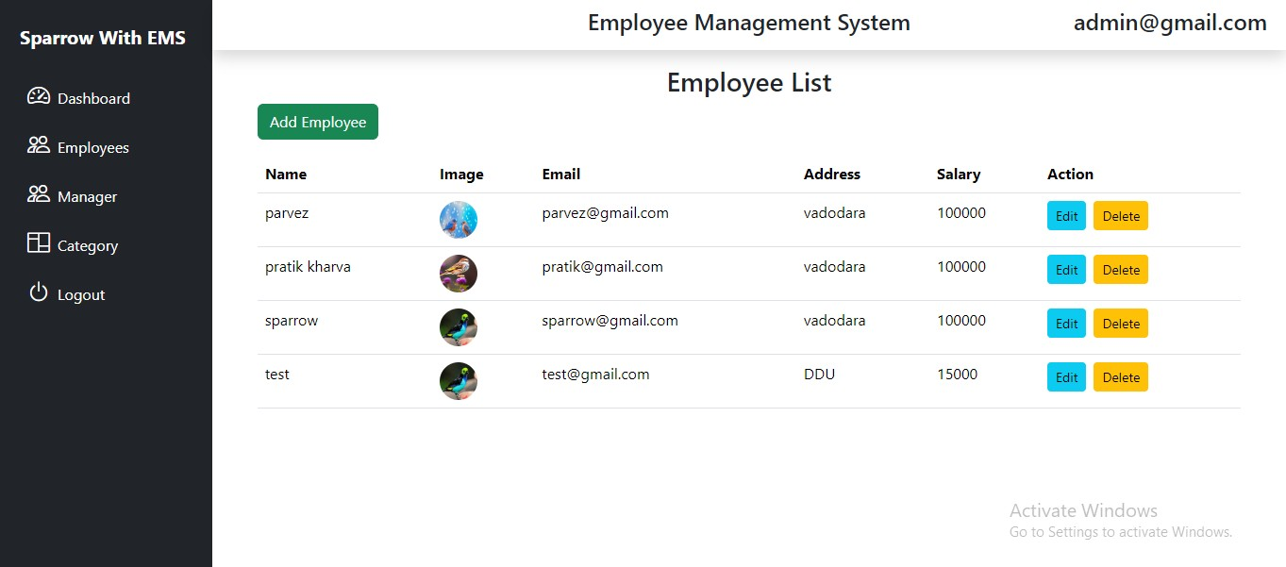

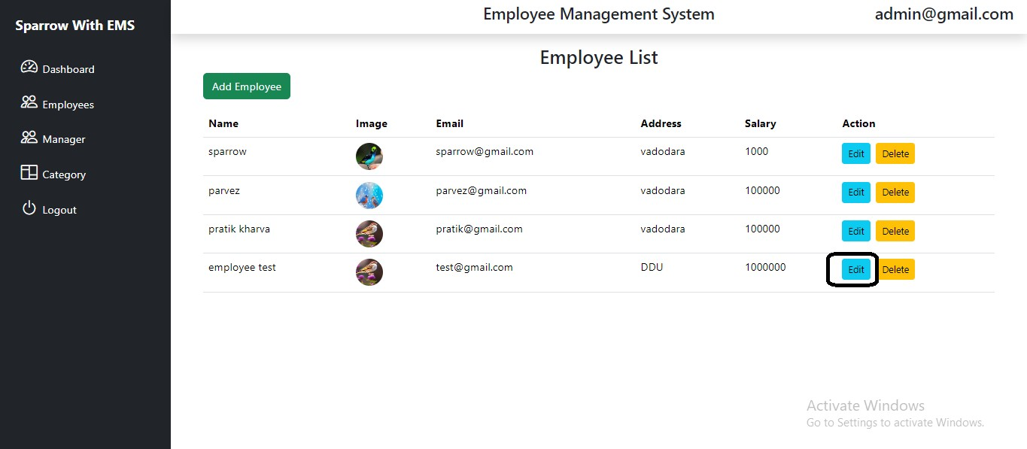

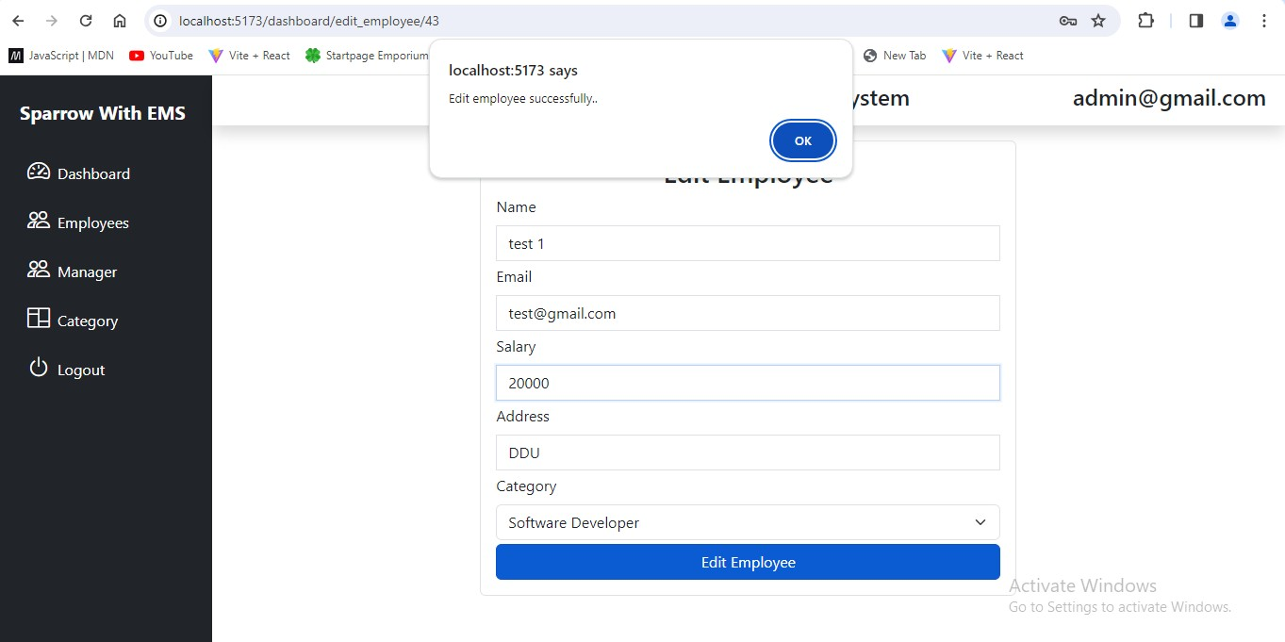

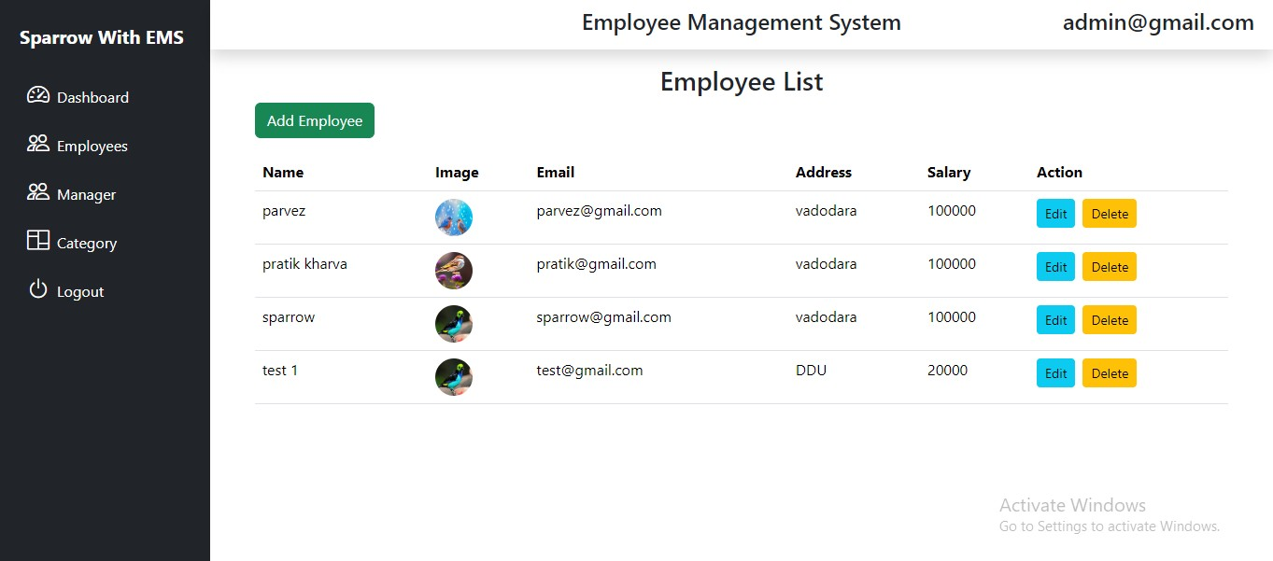

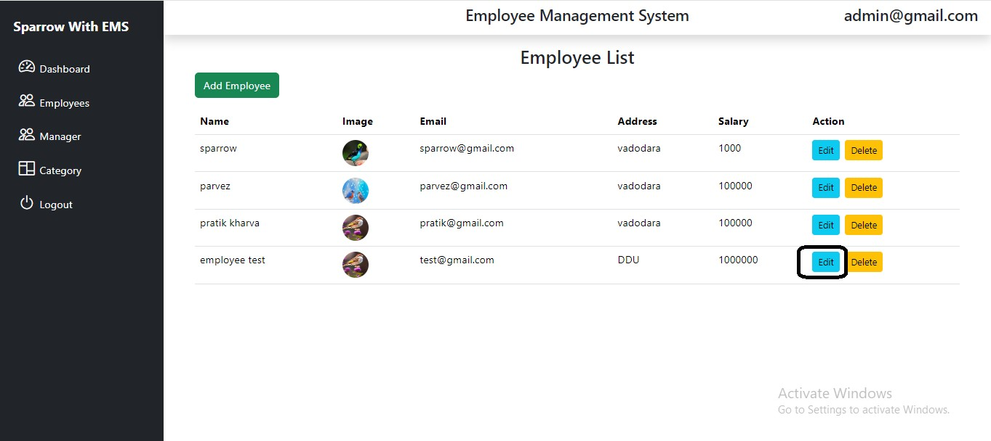

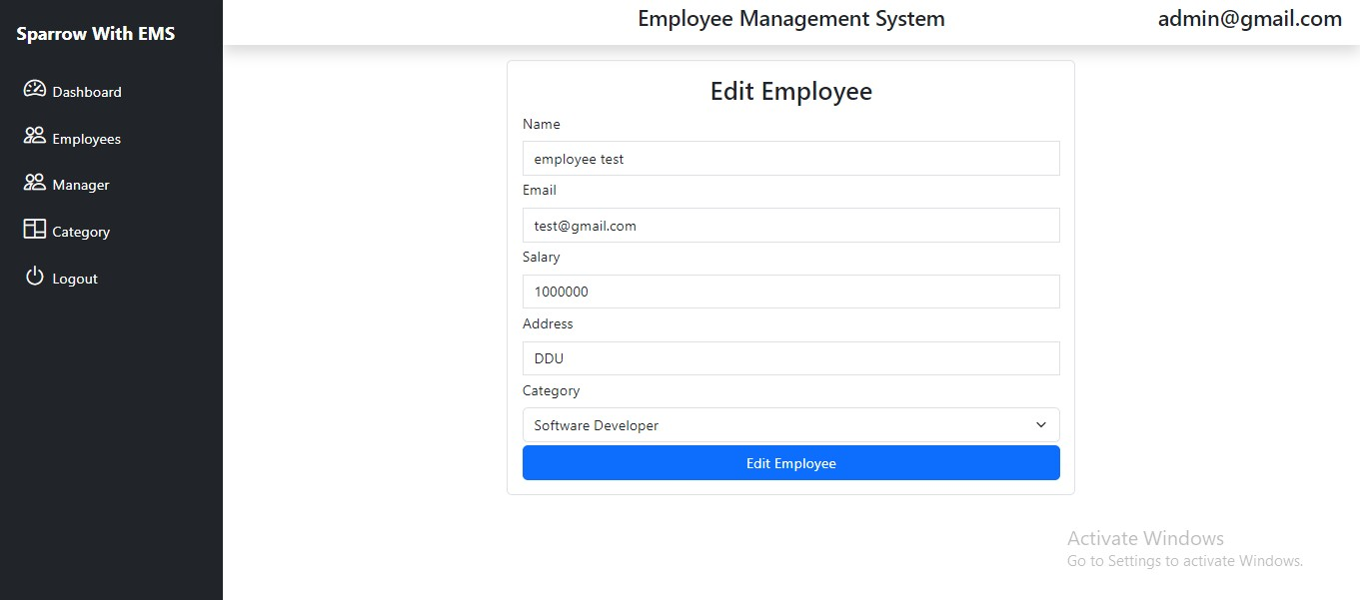

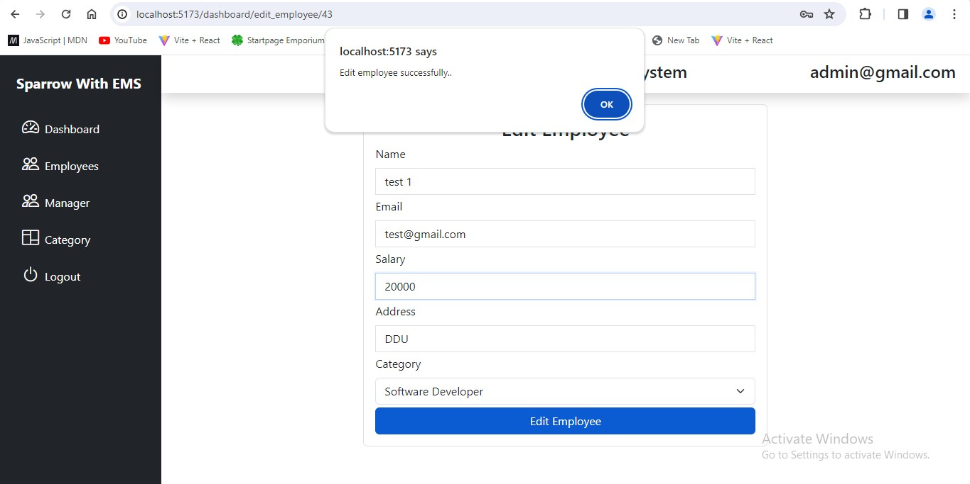

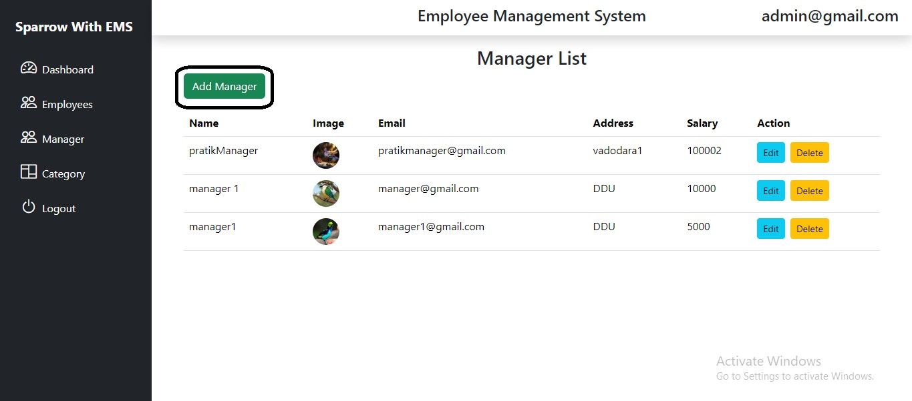

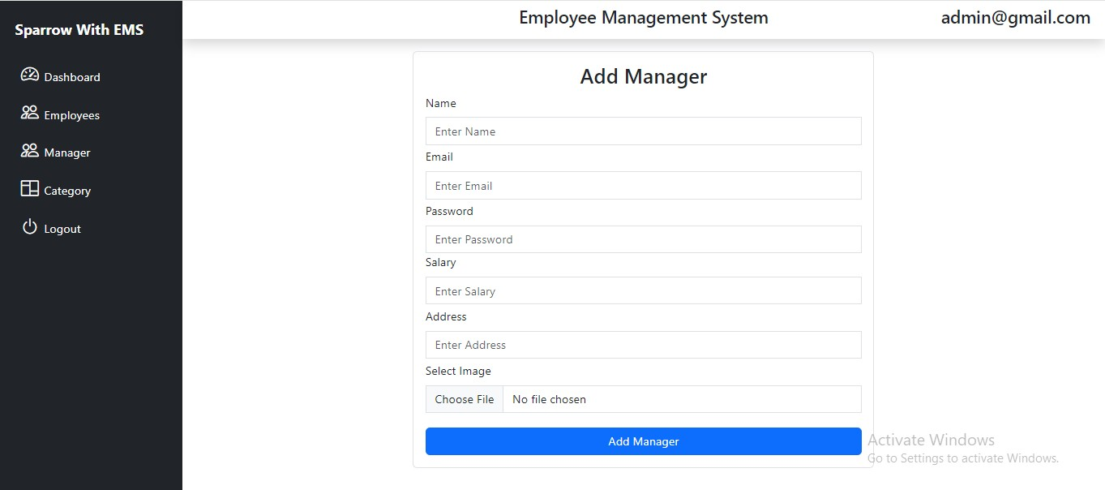

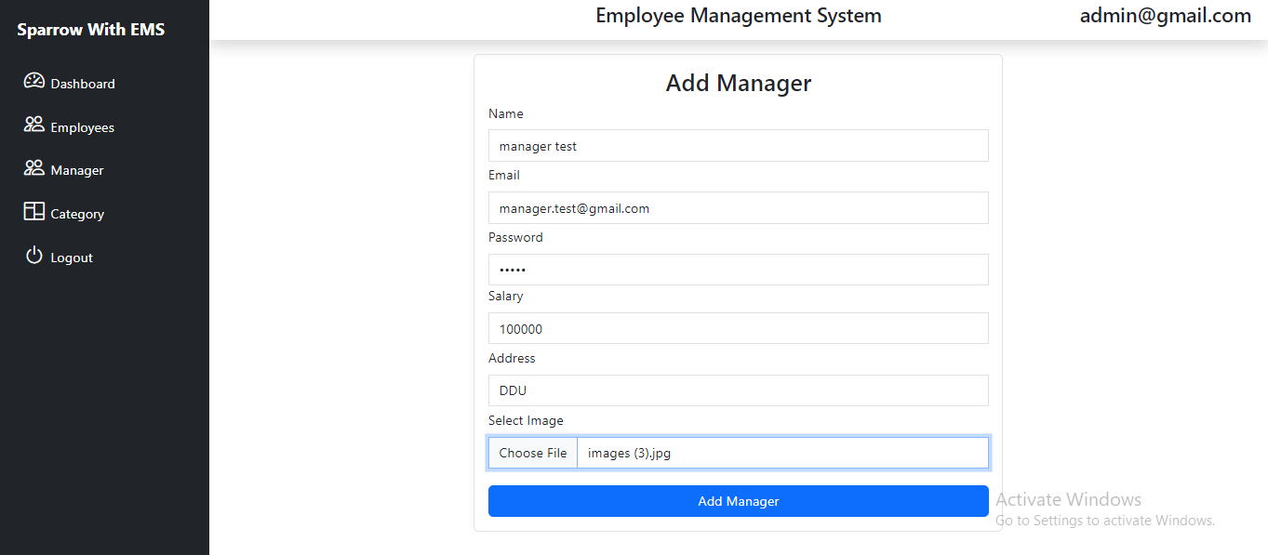

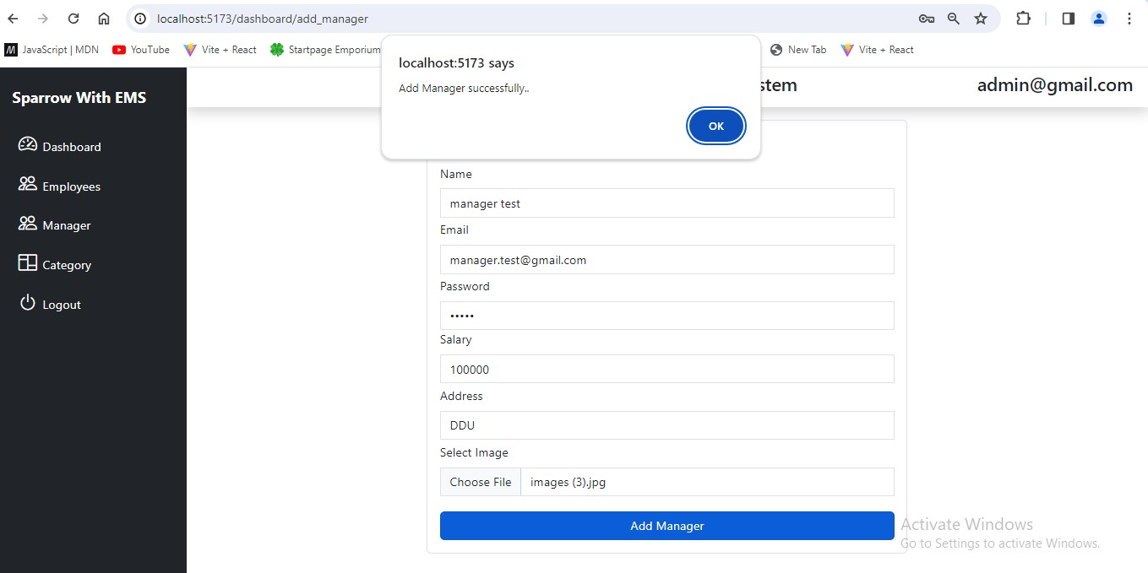

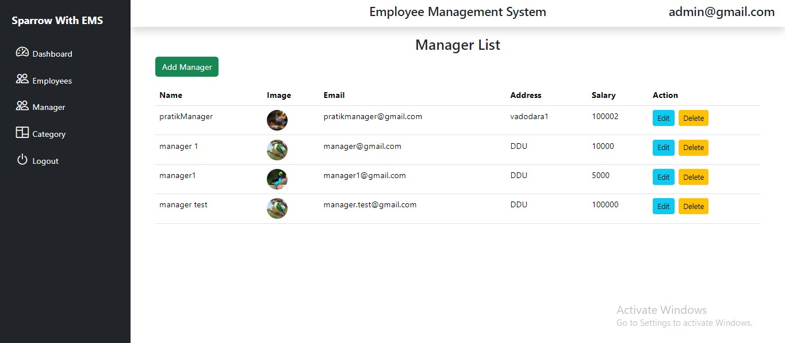

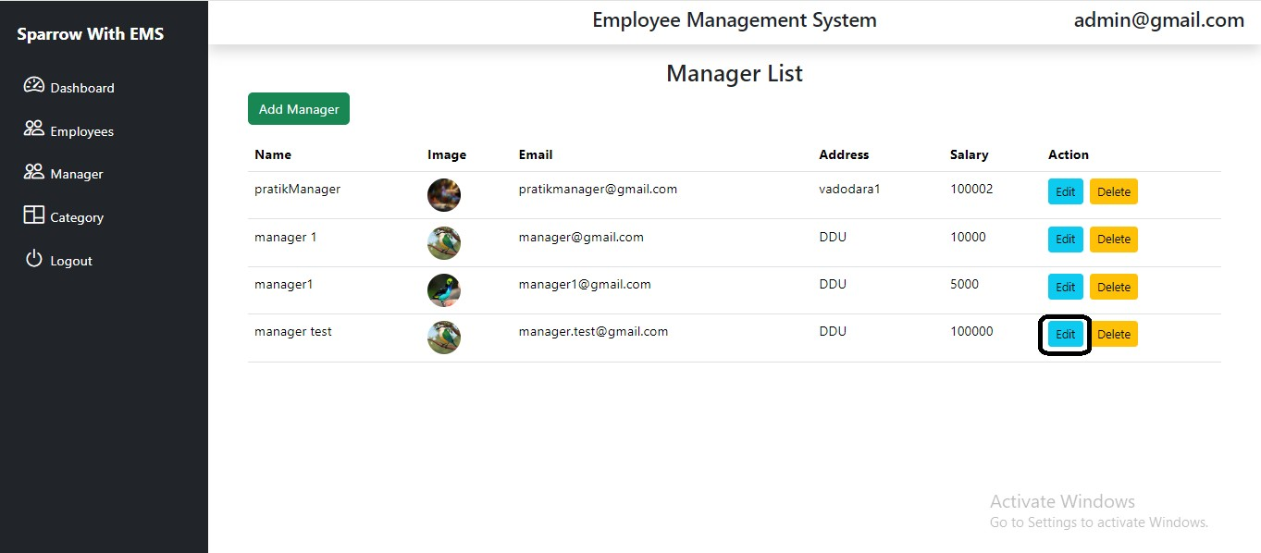

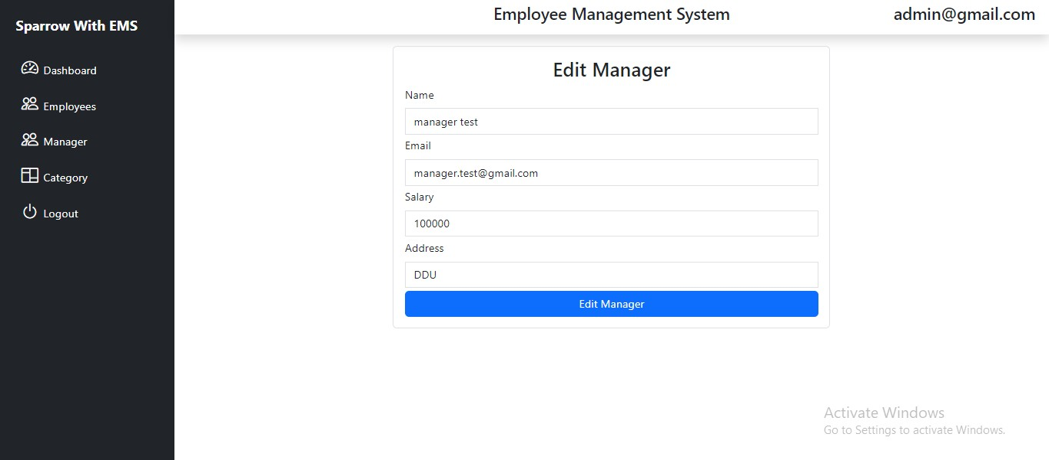

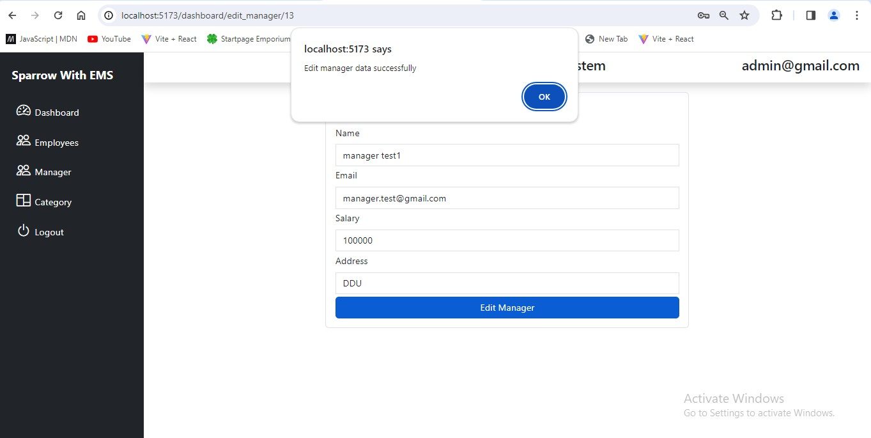

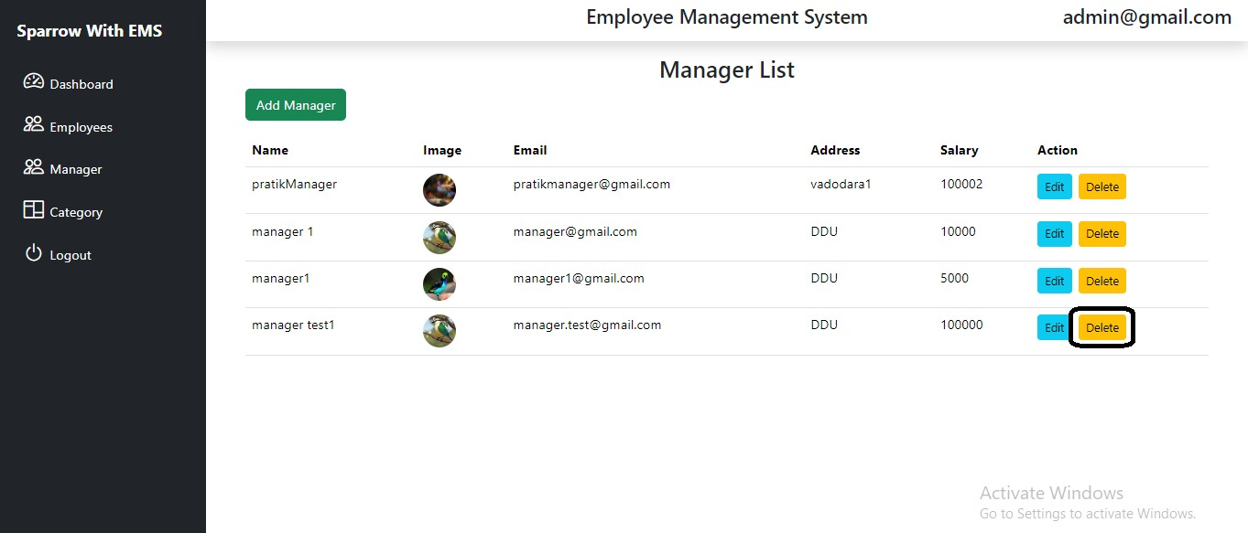

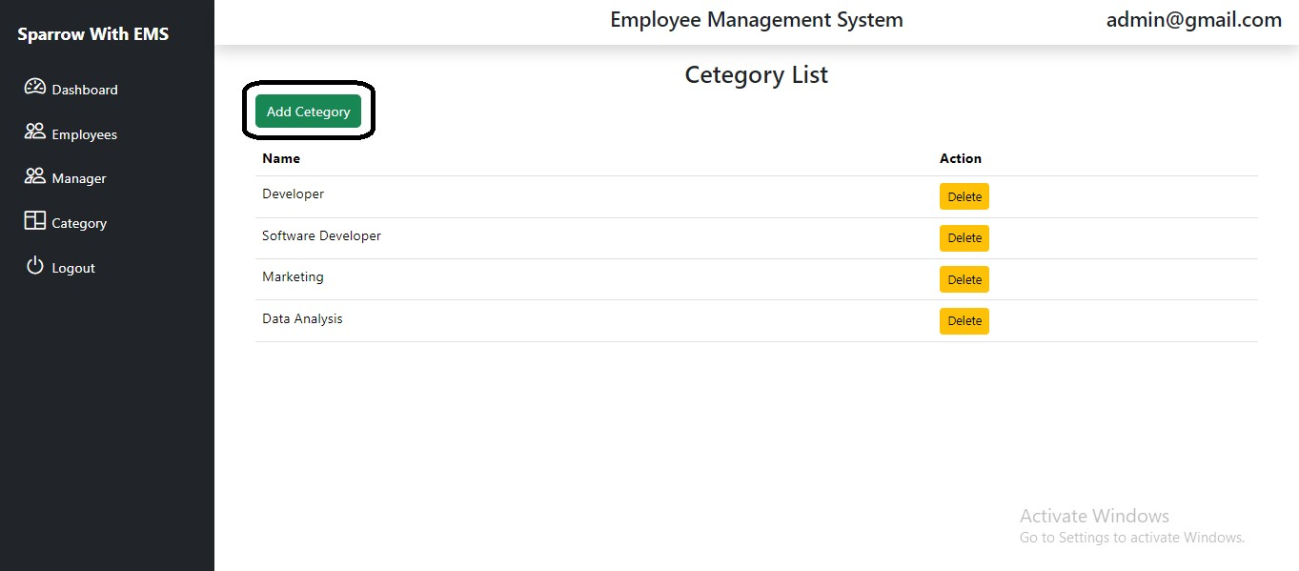

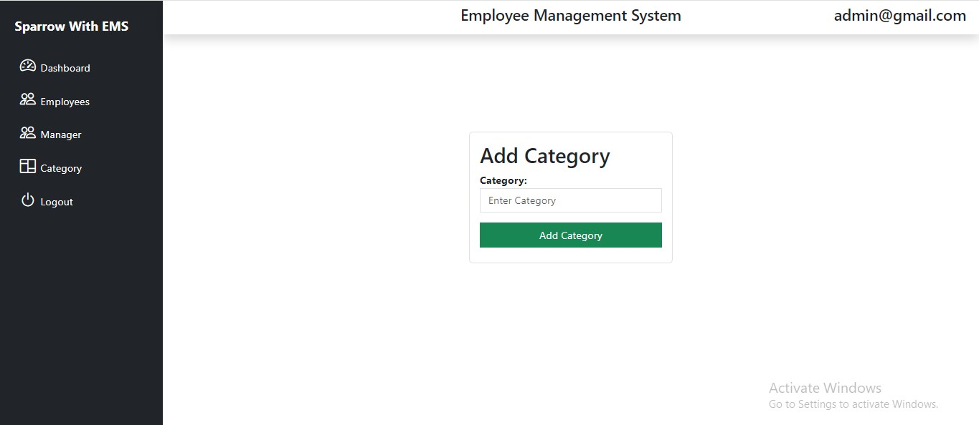

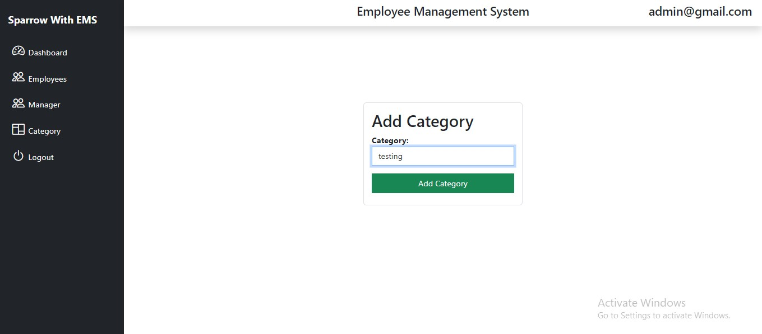

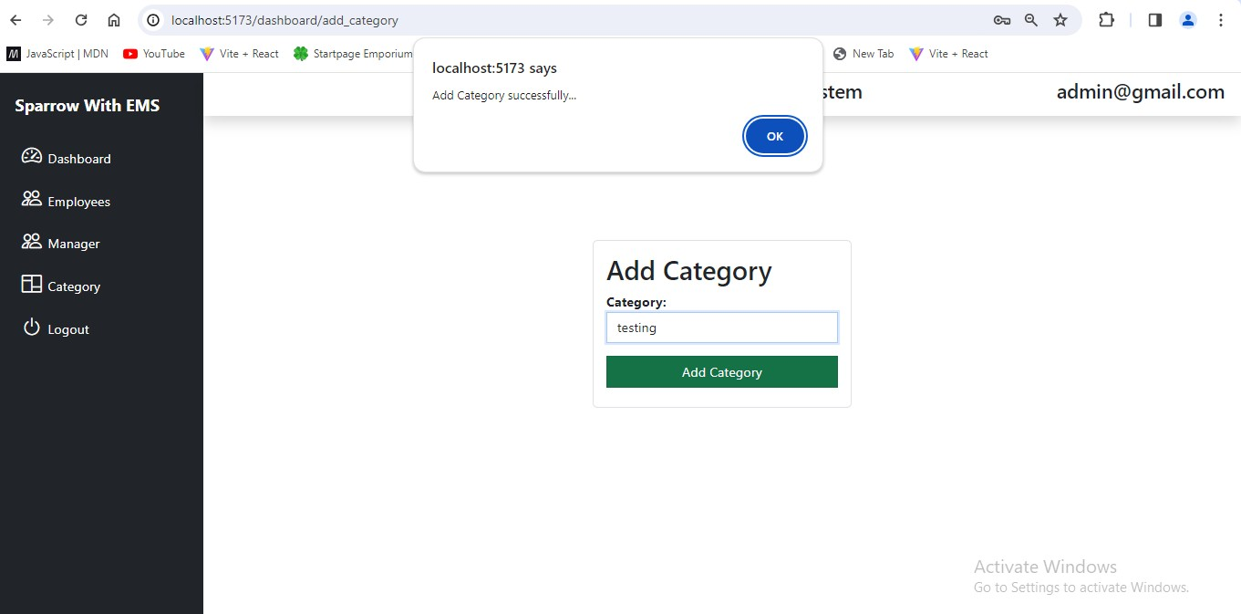

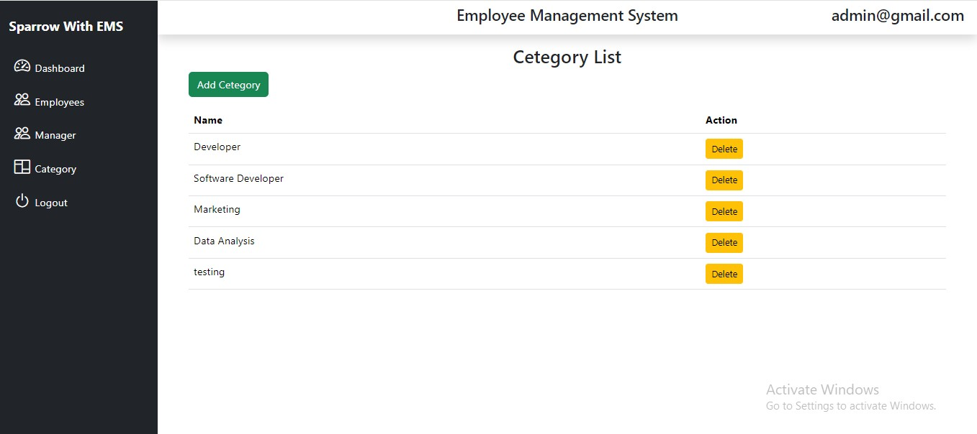

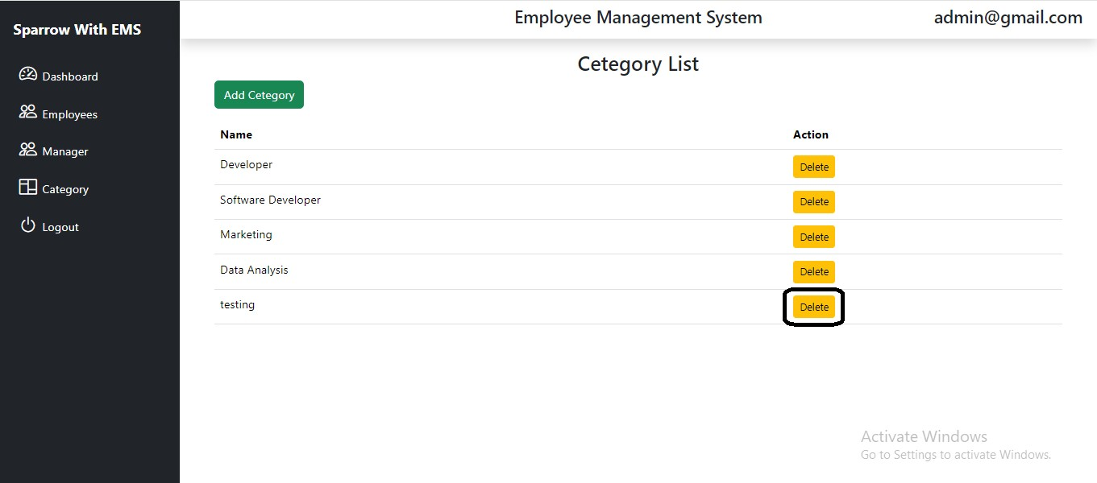

**Manager Module**

